1. **Data Import**
2. Download **northwind-db.sql** from classroom
3. Open XAMPP and Click **Explorer**
4. Copy downloaded database to **mysql** folder.
5. Open Shell from XAMPP Admin Panel.
6. Create database **<yourname>northwind** and exit

**Query:**

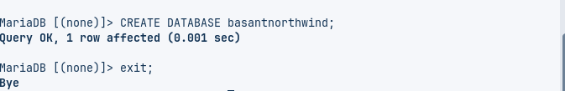

1. Import database in **<yourname>northwind** using following command at SHELL

**Query:**

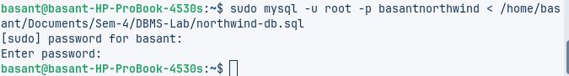

1. Connect to database using command

**Query:**

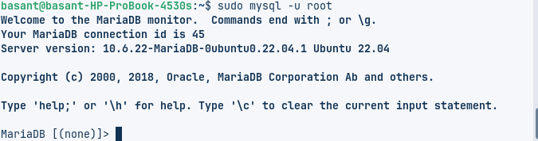

1. Use **<yourname>northwind** database using

* QUERY:
* 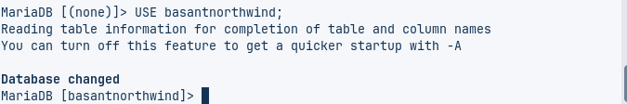
* QUERY:   
  **W TABLES:**

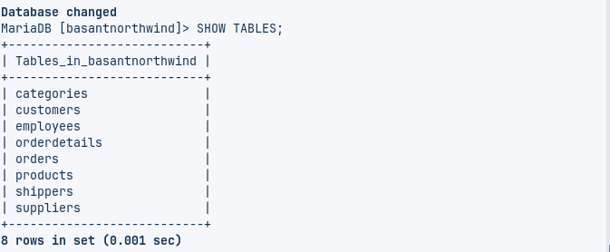

1. Check attributes and constraints in each tables i.e. **DESCRIBE <tablename>**

Customers

Query:

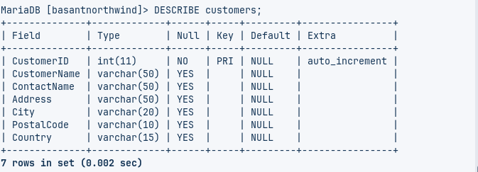

Employees  
 Query:

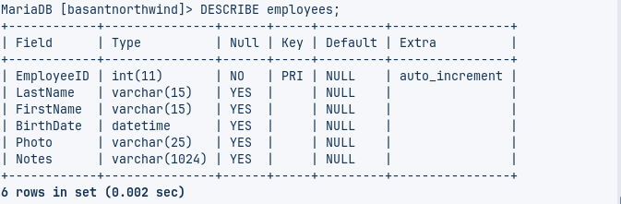

Orderdetails

Query:

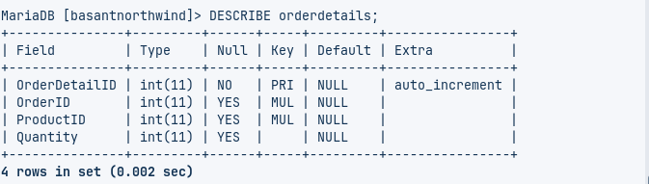

Orders  
 Query:

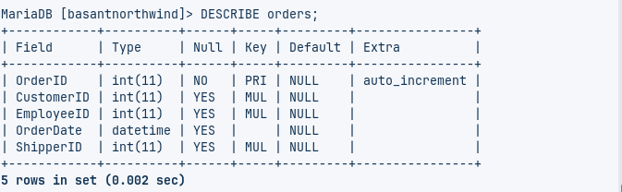

Products  
 Query:

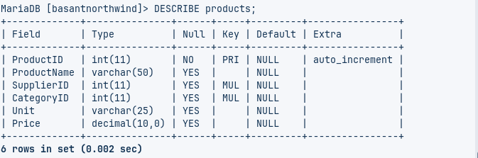

Shippers  
 Query:

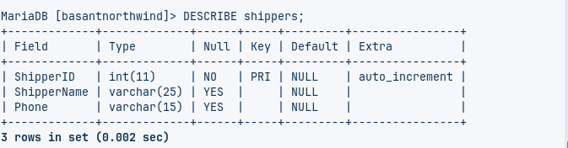

Suppliers  
 Query:

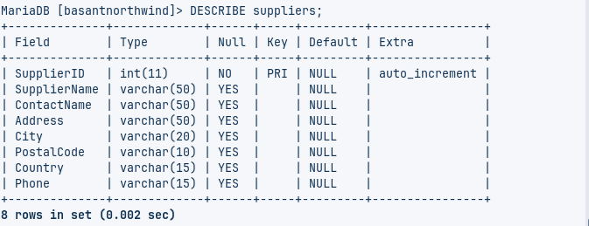

1. **Data MANIPULATION Languages (DML)**
2. Add two product categories of your choice

**Query:**

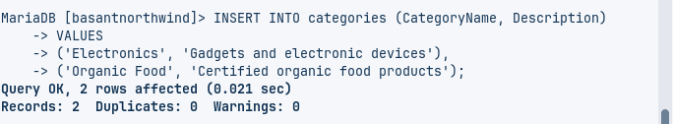

1. Add 3 new suppliers in suppliers table

**Query:**

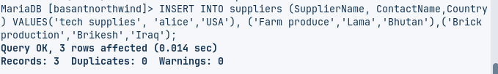

1. Add 5 new customers in customers table

**Query:**

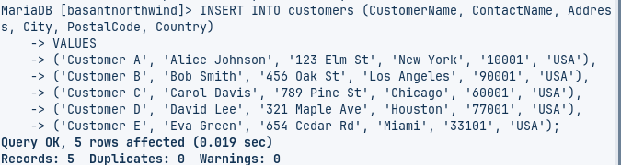

1. Add 4 products in product table

**Query:**

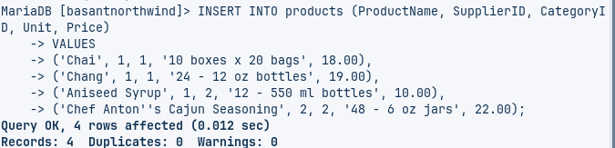

1. Add 3 new employees.

**Query:**

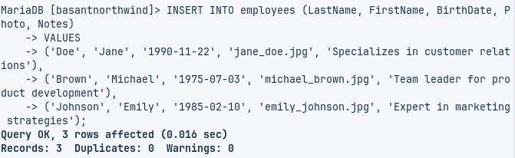

1. Update all customers from Mexico to Vietnam

**Query:**

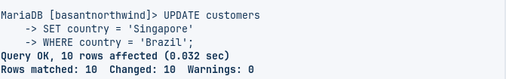

1. Update customers table changing name of Paris City to Delhi

**Query:**

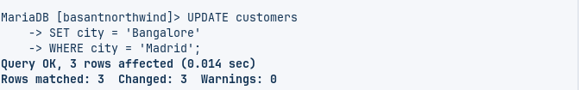

1. Update all USA customer to Indian customers

**Query:**

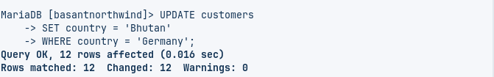

1. Convert all Brazilian customer to Combodian Customers

**Query:**

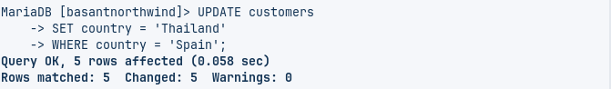

1. Convert all customers of Madrid to Kathmandu customers also change name of country

**Query:**

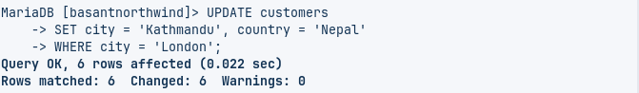

1. Convert customers from G7 Countires to SARCC Countries

**Query:**

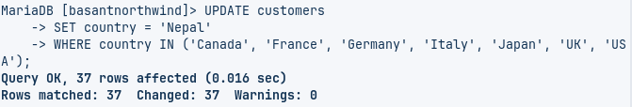

1. Delete all records from orders and orderdetails

**For Orderdetails**

**Query:**



**For Orders**

**Query:**



1. DELETE all from customers who have PostalCode containing 31

**Query:**



1. DELETE all from customers having PostalCode containing 00 and from Rome or Paris.

**Query:**



1. DELETE all from customers who are not from Salzburg

**Query:**



1. DELETE all employees who are born on July

**Query:**



1. DELETE all employees who are born on August

**Query:**



1. Find name and count of suppliers from different countries.

**Query:**

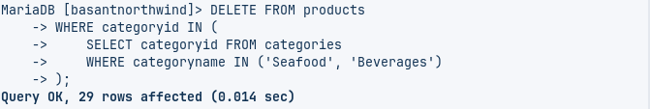

1. Find name and count of customers from different cities.

**Query:**

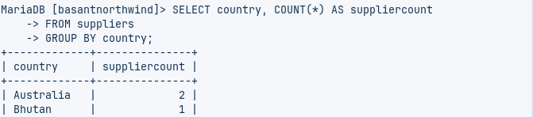

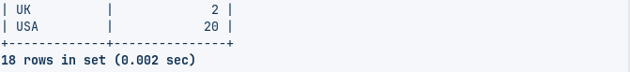

1. Find number of orders made by employee along with employeeID

**Query:**

